PEER SKILL

An Application Development-I Report Submitted
In partial fulfillment of the requirement for the award of the degree of

Bachelor of Technology
in
Computer Science and Engineering
(Artificial Intelligence and Machine Learning)
by
N. SAMANTHA NATASHA - 23N31A66L8
MD. ADHIL – 24N35A6622
M. ROHAN - 23N31A66K9

Under the esteemed Guidance of
Mr. Shiva Ratna
Associate Professor

DEPARTMENT OF COMPUTER SCIENCE AND ENGINEERING (ARTIFICIAL INTELLIGENCE AND MACHINE LEARNING)
MALLA REDDY COLLEGE OF ENGINEERING AND TECHNOLOGY
(Autonomous Institution – UGC, Govt. of India)
(Affiliated to JNTU, Hyderabad, Approved by AICTE, Accredited by NBA & NAAC – ‘A’ Grade, ISO 9001:2015 Certified) Maisammaguda (v), Near Dullapally, Via: Kompally, Hyderabad – 500 100, Telangana State, India. website: www.mrcet.ac.in
2025-2026

DECLARATION

We hereby declare that the project entitled “PEER SKILL” submitted to Malla Reddy College of Engineering and Technology, affiliated to Jawaharlal Nehru Technological University Hyderabad (JNTUH) for the award of the degree of Bachelor of Technology in Computer Science and Engineering- Artificial Intelligence and Machine Learning is a result of original research work done by us.

It is further declared that the project report or any part thereof has not been previously submitted to any University or Institute for the award of degree or diploma.

N SAMANTHA NATASHA. (23N31A66L8)
MD ADHIL (24N35A6622)
M ROHAN (23N31A66K9)


CERTIFICATE

This is to certify that this is the bonafide record of the project titled “PEER SKILL” submitted by N SAMANTHA NATASHA(23N31A66L8), MD ADHIL (24N35A6622), M ROHAN (23N31A66K9) of B. Tech in the partial fulfillment of the requirements for the degree of Bachelor of Technology in Computer Science and Engineering- Artificial Intelligence and Machine Learning, Department of CSE(Artificial Intelligence and Machine Learning) during the year 2025-2026. The results embodied in this project report have not been submitted to any other university or institute for the award of any degree or diploma.

Mr. Shiva Ratna Dr. A. Nagaraju
Associate Professor Professor
INTERNAL GUIDE HEAD OF THE DEPARTMENT

EXTERNAL EXAMINER

Date of Viva-Voce Examination held on:___________________
ACKNOWLEDGEMENT

The Application Development I work carried out by our team in the Department of CSE (Artificial Intelligence and Machine Learning), Malla Reddy College of Engineering and Technology, Hyderabad. This work is original and has not been submitted in part or full for any degree or diploma of any other university.
We wish to acknowledge our sincere thanks to our project guide Mr. Shiva Ratna, Associate Professor for formulation of the problem, analysis, guidance and his continuous supervision during the course of work.
We acknowledge our sincere thanks to Dr. Vaka Murali Mohan, Principal, Dr.A NAGARAJU , Head of the Department and Mrs. T Jayasri, Coordinator, faculty members of CSE(AI&ML) Department for their kind cooperation in making this Application Development I work a success.
We extend our gratitude to Sri. Ch. Malla Reddy, Founder Chairman MRGI and Sri. Ch. Mahender Reddy, Secretary MRGI, Dr. Ch. Bhadra Reddy, President MRGI, Sri. Ch. Shalini Reddy, Director MRGI, Sri. P. Praveen Reddy, Director MRGI, for their kind cooperation in providing the infrastructure for completion of our Application Development I.
We acknowledge our special thanks to the entire teaching faculty and non-teaching staff members of the CSE (Artificial Intelligence and Machine Learning) Department for their support in making this project work a success.

N SAMANTHA NATASHA - 23N31A66L8
MD ADHIL – 24N35A6622
M ROHAN - 23N31A66K9

ABSTRACT
Peer Skill is an innovative web-based peer-to-peer learning platform designed to enable users to exchange skills without any financial transactions. In traditional learning systems, access to quality education is often limited by cost, availability, and lack of personalized interaction. Peer Skill addresses these challenges by creating a collaborative environment where users can both teach and learn from each other based on their individual skills and interests..
The platform allows users to create profiles, list the skills they can offer, and specify the skills they wish to learn. A smart matching system connects users with compatible learning partners by analyzing their skill sets, preferences, and availability. Additionally, the platform provides features such as session scheduling, real-time communication, feedback and rating systems, and a reputation-based credit mechanism to ensure trust and continuous engagement within the community.
Built using modern web technologies such as React.js for the frontend, Node.js or Django for the backend, and a scalable database system, Peer Skill ensures efficiency, usability, and accessibility across devices. The system aims to promote inclusive and community-driven learning by removing financial barriers and encouraging knowledge sharing.
In the future, Peer Skill can be enhanced with AI-based recommendations, mobile application support, and certification systems to further improve user experience and learning outcomes. Overall, the platform has the potential to transform traditional learning methods into a more interactive, accessible, and sustainable knowledge-sharing ecosystem.
TABLE OF CONTENTS

CONTENTS Page No.

INTRODUCTION 8
  - Problem Statements 9
  - Objectives 10

LITERATURE SURVEY 11
  - Existing System 11
  - Proposed System 12

SYSTEM REQUIREMENTS 14
  - Software and Hardware Requirement 14
  - Functional and Non-Functional Requirements 15
  - Other Requirements 16

SYSTEM DESIGN 18
  - Architecture Diagram 18
  - UML Diagrams 19

IMPLEMENTATION 23
  - Algorithms 23
  - Architectural Components 24
  - Feature Extraction 25
  - Packages/Libraries Used 26
  - Source Code 28
  - Output Screens 37

SYSTEM TESTING 45
  - Test Cases 45
  - Results and Discussions 49
    - Datasets 50
  - Performance Evaluation 51

CONCLUSION & FUTURE ENHANCEMENTS 53

REFERENCES 56

LIST OF FIGURES

Fig. No | Figure Title | Page no.
4.1 | Architecture Diagram | 18
4.2.1 | Use Case Diagram | 19
4.2.2 | Class Diagram | 20
4.2.3 | Sequence Diagram | 21
4.2.4 | Activity Diagram | 22
5.1 | Browser Link | 37
5.2 | AarogyaLink Symptom Analysis Home Page | 38
5.3 | Symptom Analysis Form AarogyaLink | 39
5.4 | Symptom Analysis Input Form AarogyaLink | 40
5.5 | Medical Reports and Insurance Details | 41
5.6 | Symptom Analysis Input Form AarogyaLink | 42
5.7 | Recommended Hospitals List Based on Patient Details | 43
5.8 | Healthcare Platform Performance | 44

LIST OF TABLES

S. No | Table Name | Page No
6.1 | Test Cases | 45

LIST OF ABBREVIATIONS

S. No | ABBREVIATIONS
1. | API: Application Programming Interface
2 | UML: Unified Modeling Language
3 | vCPU: virtual Central Processing Unit
4 | CORS: Cross-Origin Resource Sharing
5 | CI/CD: Continuous Integration/Continuous Deployment
6 | JSON: JavaScript Object Notation
7 | EHR: Electronic Health Records
8 | NGOs: Non-Governmental Organizations

CHAPTER-1 INTRODUCTION
The rapid growth of digital technology has significantly transformed the way people learn and share knowledge. However, despite the availability of numerous online learning platforms, access to quality education often remains restricted due to high costs, lack of personalization, and limited interaction between learners and instructors. Most existing systems follow a one-way learning approach, where users consume content rather than actively engaging in knowledge exchange. This creates a gap between individuals who possess valuable skills and those who are eager to learn but lack resources or opportunities.
In today’s world, many individuals have practical skills and expertise that remain underutilized due to the absence of a suitable platform to share them. At the same time, learners are constantly searching for flexible, affordable, and personalized learning experiences. This imbalance highlights the need for a system that can connect people based on their skills and learning interests while promoting mutual growth and collaboration.
To address these challenges, the Peer Skill platform is introduced as a peer-to-peer learning system that enables users to exchange skills instead of relying on paid courses. The platform allows users to create profiles, list the skills they can teach, and specify the skills they wish to learn. Using a smart matching mechanism, the system connects users with compatible partners, enabling effective and meaningful knowledge exchange.
In addition to skill matching, the platform provides essential features such as session scheduling, real-time communication, feedback and rating systems, and a reputation-based credit mechanism. These features ensure a structured, interactive, and trustworthy learning environment where users can actively participate as both learners and instructors..
The system is developed using modern web technologies, ensuring scalability, usability, and accessibility across multiple devices. By removing financial barriers and promoting collaborative learning, Peer Skill aims to create an inclusive and community-driven educational ecosystem. The platform not only enhances skill development but also encourages continuous learning, networking, and knowledge sharing among individuals.
Ultimately, Peer Skill represents a shift from traditional learning methods to a more interactive, flexible, and user-centric approach, empowering individuals to learn and grow together in a connected digital environment.

1.1 Problem Statements:
In the current digital era, access to quality education and skill development remains a significant challenge for many individuals due to financial constraints, lack of personalized learning, and limited opportunities for practical knowledge exchange. Most existing online learning platforms operate on a paid model, requiring users to purchase courses or subscriptions, which creates a barrier for students and individuals from economically weaker backgrounds.

Additionally, traditional e-learning systems follow a one-directional approach, where learners passively consume content without meaningful interaction or collaboration. These platforms often fail to provide personalized learning experiences or connect individuals based on mutual interests and skill sets. As a result, many users struggle to find relevant mentors or learning partners who can guide them effectively.

Another major limitation of current systems is the underutilization of individual skills within communities. Many people possess valuable knowledge and practical expertise but lack a platform to share their skills with others. At the same time, learners are unable to access these resources due to the absence of a structured system that facilitates peer-to-peer knowledge exchange.

Furthermore, existing platforms do not emphasize community-driven learning, real-time collaboration, or mutual growth. They lack features such as intelligent skill matching, interactive communication, flexible scheduling, and trust-building mechanisms like feedback and reputation systems. This leads to a disconnected learning experience that does not fully utilize the potential of collaborative education.

Therefore, there is a strong need for an innovative platform that enables users to both teach and learn by exchanging skills without financial barriers. Such a system should provide intelligent matching, real-time interaction, and a structured environment to promote collaborative, accessible, and efficient learning. The proposed Peer Skill platform aims to address these challenges by creating a community-driven ecosystem where knowledge sharing becomes seamless, inclusive, and mutually beneficial.

1.2 Objectives:
The primary objective of the Peer Skill project is to develop a collaborative peer-to-peer learning platform that enables users to exchange skills without any financial barriers. The system aims to create an inclusive environment where individuals can both teach and learn based on their knowledge, interests, and availability.
One of the key objectives is to design and implement an intelligent skill-matching mechanism that connects users with compatible learning partners. By analyzing the skills users can offer and the skills they wish to learn, the platform ensures effective and meaningful knowledge exchange between participants.
Another important objective is to provide a structured and user-friendly system that supports essential functionalities such as user registration, profile management, skill listing, and session scheduling. These features help users organize their learning activities efficiently and participate in planned learning sessions.

The platform also aims to facilitate real-time communication between users through messaging or chat features, enabling interactive and engaging learning experiences. In addition, a feedback and rating system is introduced to maintain quality, build trust, and encourage active participation within the community.

Furthermore, the project focuses on developing a credit or reputation-based system that rewards users for their contributions, such as teaching or actively participating in sessions. This mechanism motivates users to remain engaged and continuously share their knowledge.

From a technical perspective, the objective is to build the system using modern and scalable web technologies, ensuring high performance, security, and accessibility across different devices. The platform should be capable of handling multiple users while maintaining a smooth and responsive user experience.

Finally, the long-term objective of the Peer Skill platform is to promote community-driven learning, reduce dependency on paid educational resources, and create a sustainable ecosystem where knowledge sharing becomes accessible, interactive, and beneficial for everyone.

CHAPTER 2
LITERATURE SURVEY

The study of existing learning platforms and knowledge-sharing systems reveals that most digital education solutions are designed primarily for content delivery rather than interactive and collaborative learning. While these platforms have improved accessibility to educational resources, they still lack mechanisms that enable mutual skill exchange and personalized peer-based learning. The literature survey highlights the limitations of current systems and establishes the need for a more collaborative and community-driven approach like the Peer Skill platform.

  - Existing System:

2.1.1 Paid Learning Platforms
Most popular online learning platforms operate on a subscription or course-purchase model. While they provide structured content, they restrict access for users who cannot afford to pay. This creates a financial barrier and limits equal learning opportunities.

2.1.2 One-Way Learning Approach
Existing systems generally follow a one-directional model where instructors deliver content and learners consume it. There is minimal interaction, and users cannot actively contribute as both learners and teachers. This reduces engagement and limits practical knowledge sharing.

2.1.3 Lack of Personalized Matching
Current platforms do not provide intelligent matching between users based on skills. Learners often struggle to find mentors or peers who match their learning requirements, leading to inefficient learning experiences.

2.1.4 Limited Community Interaction
Although some platforms offer discussion forums, they lack real-time collaboration features such as direct messaging, peer sessions, or interactive scheduling. This results in a disconnected learning environment.

2.1.5 Underutilization of Skills
Many individuals possess valuable skills but do not have a platform to share their knowledge. Existing systems fail to utilize this untapped potential within communities, resulting in missed opportunities for collaborative growth.
  - Proposed System:
The proposed system, Peer Skill, addresses the limitations of existing platforms by introducing a peer-to-peer skill exchange model that promotes collaborative and accessible learning.

2.2.1 Skill Exchange Mechanism
Unlike traditional platforms, Peer Skill enables users to exchange skills instead of paying for courses. Users can teach what they know and learn what they need, creating a mutually beneficial ecosystem.

2.2.2 Intelligent Skill Matching
The system incorporates a matching algorithm that connects users based on complementary skills. This ensures that learning sessions are relevant, personalized, and effective.

2.2.3 Interactive Learning Environment
Peer Skill provides real-time communication features such as chat and session scheduling, enabling users to interact, collaborate, and learn actively.

2.2.4 Feedback and Reputation System
To maintain quality and trust, the platform includes a rating and feedback mechanism. Users can evaluate each session, helping others make informed decisions.

2.2.5 Community-Driven Learning
The system promotes a collaborative environment where users contribute as both learners and teachers. This approach encourages continuous engagement and knowledge sharing within the community.

CHAPTER 3

SYSTEM REQUIREMENTS

  - Software and Hardware Requirements
    - Software Requirements
- Operating System: Windows 10 or later
Provides a stable platform for development and testing of the AarogyaLink application. Ensures compatibility with modern development tools and seamless integration with cloud deployment services. Since the application is web-based, end-users can access it through any operating system using a standard browser.
- Front-End Framework: React.js
Used to design a responsive and interactive user interface for patients and hospital administrators. Supports dynamic rendering of pages, easy navigation, and a cross-platform experience on desktops and mobile devices.
- Back-End Programming Language: Node.js with Express.js
Serves as the runtime environment for server-side operations and manages communication between frontend and backend. Express.js simplifies routing, handles API requests, and ensures secure and efficient data transfer.
- Core APIs Integration :
Google Gemini API: Performs AI-driven symptom analysis and suggests possible diagnoses.
Google Places API: Provides real-time data on nearby hospitals and healthcare facilities.
Google Geocoding API: Converts addresses to geographic coordinates for accurate hospital location mapping.
- Deployment Platforms: Vercel & Render
Vercel is used for hosting the frontend, while Render is employed for backend deployment. Both platforms ensure scalability, high uptime, and smooth application performance.

    - Hardware Requirements
Server Requirements
- Processor: A minimum of 1 vCPU on a cloud instance is required to efficiently run the backend services and manage multiple user requests simultaneously.
  - Memory: At least 512 MB RAM or higher is necessary to ensure smooth execution of server-side processes and handle real-time operations without delays.
  - Storage: A minimum of 5 GB storage capacity is required to maintain application data, logs, and API-related cache for uninterrupted performance.
  - Deployment: The system should run on a standard cloud instance capable of supporting Node.js runtime and seamless integration with APIs like Google Gemini and Google Places.
Client Requirements
  - Device: Any modern desktop, laptop, or smartphone can be used by patients and administrators to access the application through a web browser.
  - Operating System: The platform supports multiple operating systems including Windows, macOS, Android, and iOS, ensuring cross-platform compatibility.
  - Browser: A modern web browser such as the latest version of Google Chrome, Microsoft Edge, or Mozilla Firefox is essential for full functionality.
  - Internet Connectivity: A stable broadband or mobile internet connection is required to access real-time hospital data and ensure uninterrupted user experience.

3.2. Functional and Non-Functional Requirements:
Functional Requirements:
- Symptom Analysis and Diagnosis: The system analyzes patient-reported symptoms using the Google Gemini API to provide a potential diagnosis and medical guidance.
- Hospital Search and Mapping: Integration with Google Places and Geocoding APIs enables the system to recommend nearby hospitals and map their exact locations.
- Scheme and Insurance Filtering: Patients can filter hospital results based on accepted government health schemes and insurance policies for financial transparency.
- Hospital Ranking System: The system ranks hospitals using a relevance score based on specialty alignment, patient ratings, and scheme compatibility.
- Administrative Panel: A secure interface allows hospital administrators to update facility details, supported schemes, and services in real time.
- User Dashboard: Patients are provided with a simple dashboard that displays diagnosis results, recommended hospitals, and filter options.

Non-Functional Requirements:

- Performance: The system must process API requests quickly, delivering symptom analysis and hospital results within 2–3 seconds for a smooth user experience.
- Scalability: The architecture must support a growing number of users by leveraging cloud deployment platforms such as Vercel and Render.
- Security: Sensitive user information, such as medical records and personal details, must be encrypted and protected with role-based access.
- Usability: The interface should be intuitive, responsive, and accessible on both desktop and mobile devices with minimal technical knowledge required.
- Reliability: The system must maintain at least 99% uptime with auto-recovery mechanisms to ensure continuous service availability.
- Adaptability: AarogyaLink should support different hospital databases, healthcare schemes, and be flexible enough to expand into new regions or insurance models in the future.

Other Requirements :

- Testing Requirements: The system must be thoroughly tested to ensure accuracy and reliability. Unit tests should be carried out for the AI-based diagnosis module, while integration tests must verify smooth communication between the frontend, backend, and APIs (Google Gemini, Google Places, and Google Geocoding). Stress testing should confirm that the system can handle high loads, with at least 1,000 concurrent users accessing the platform without major performance drops.

- Training and Support Requirements: Hospital administrators need training to effectively use the administrative panel for updating hospital data, supported schemes, and services. Comprehensive documentation and tutorials must be provided to simplify learning. Additionally, a 24/7 technical support service should be available for both patients and administrators to resolve issues quickly and ensure uninterrupted system operation.

- Data Privacy and Compliance Requirements: Since AarogyaLink handles sensitive health-related information, strict measures for data protection must be in place. All user information should be encrypted, and access must be role-based to prevent unauthorized use. The system must comply with healthcare data protection guidelines and ensure that users provide informed consent before their data is processed or shared.

- Stakeholder Communication Requirements: The platform must include feedback and communication features to keep stakeholders engaged. Patients should be able to provide reviews and suggestions, while hospitals and administrators should receive regular reports on system usage. Government health authorities should also be able to access dashboards that highlight scheme usage, hospital participation, and overall system effectiveness.

CHAPTER 4

SYSTEM DESIGN

4.1 Architecture Diagram
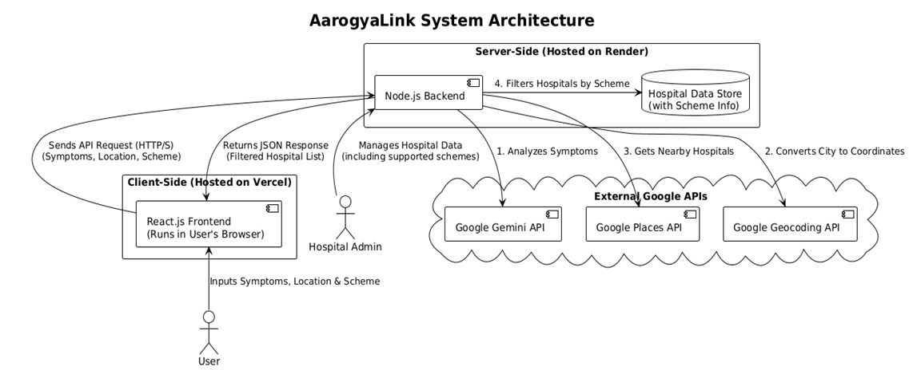
Fig 4.1 System Architecture of AarogyaLink: A Smart Health Hub for Scheme Navigation and Medical Records

4.2 UML Diagrams

4.2.1 Use case diagram

Use Case during requirement elicitation and analysis to represent the functionality of the system. Use case describes a function by the system that yields a visible result for an actor. The identification of actors and use cases result in the definitions of the boundary of the system i.e., differentiating the tasks accomplished by the system and the tasks accomplished by its environment.

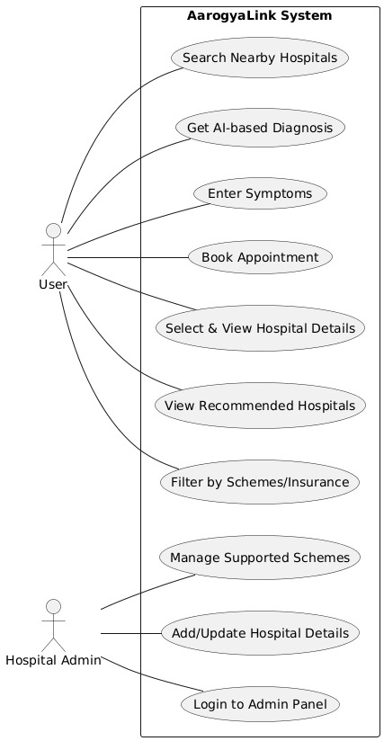
Fig 4.2.1 Use Case Diagram of AarogyaLink: A Smart Health Hub for Scheme Navigation and Medical Records

4.2.2 Class Diagram
Class diagrams model class structure and contents using design elements such as classes, packages and objects. Class diagram describe the different perspective when designing a system-conceptual, specification and implementation. Classes are composed of three things: name, attributes, and operations. Class diagram also display relationships such as containment, inheritance, association etc. The association relationship is most common relationship in a class diagram. The association shows the relationship between instances of classes.
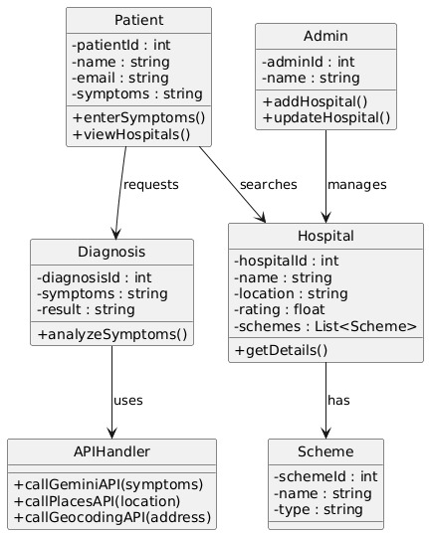

Fig 4.2.2 Class Diagram of AarogyaLink: A Smart Health Hub for Scheme Navigation and Medical Records

4.2.3 Sequence Diagram

Sequence diagram displays the time sequence of the objects participating in the interaction. This consists of the vertical dimension (time) and horizontal dimension (different objects).
Objects: An object can be thought of as an entity that exists at a specified time and has a definite value, as well as a holder of identity. A sequence diagram depicts item interactions in chronological order. It illustrates the scenario's objects and classes, as well as the sequence of messages sent between them in order to carry out the scenario's functionality. In the Logical View of the system under development, sequence diagrams are often related with use case realizations. Event diagrams and event scenarios are other names for sequence diagrams. A sequence diagram depicts multiple processes or things that exist simultaneously as parallel vertical lines (lifelines), and the messages passed between them as horizontal arrows, in the order in which they occur. This enables for the graphical specification of simple runtime scenarios.
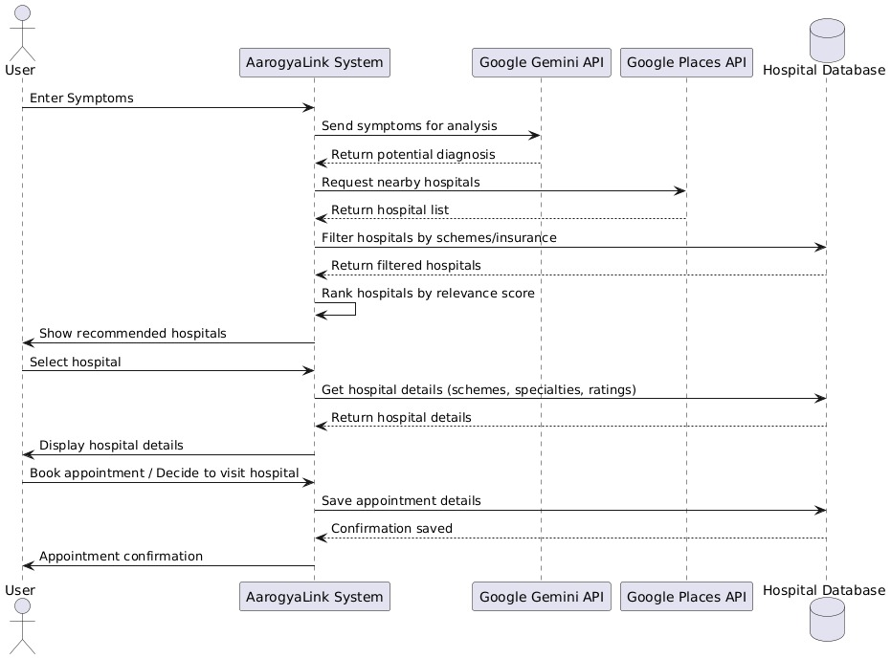

Fig 4.2.3 Sequence Diagram of AarogyaLink: A Smart Health Hub for Scheme Navigation and Medical Records
4.2.4 Activity Diagram

The process flows in the system are captured in the activity diagram. Similar to a state diagram, an activity diagram also consists of activities, actions, transitions, initial and final states, and guard conditions

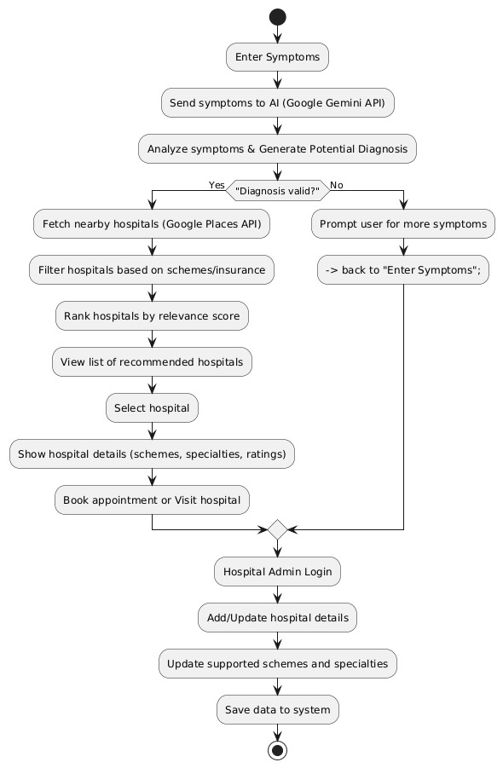

Fig 4.2.4 Activity Diagram of AarogyaLink: A Smart Health Hub for Scheme Navigation and Medical Records

CHAPTER 5

IMPLEMENTATION

The implementation of AarogyaLink combines AI-powered diagnosis with real-time hospital search to assist users effectively. The system uses the Google Gemini API to analyze user symptoms and provide possible conditions, while the Google Places and Geocoding APIs help locate nearby hospitals accurately. An advanced relevance scoring method ranks hospitals by specialty, ratings, and availability, with a fallback option to suggest general hospitals when specialists are not found. A simple Admin Panel is provided for hospitals to add their details, ensuring updated data. To enhance performance, the backend processes hospital information in parallel, and all sensitive keys are secured using environment variables. The application is deployed with the frontend on Vercel and the backend on Render, making it reliable and accessible.
5.1 Algorithms :
The algorithms in this project help to make the system more accurate and user-friendly. They analyze user symptoms to provide a possible diagnosis, search and locate nearby hospitals, filter them based on scheme or insurance support, and recommend the most suitable options by considering important factors like distance, specialty, and ratings. Together, these steps ensure that patients get quick, reliable, and financially accessible healthcare guidance.
5.1.1 Symptom Analysis Algorithm:
- Input: User’s symptoms (text).
- Process: Sent to Google Gemini API with structured prompts (including user details like age/gender).
- Output: Ranked list of possible conditions, common illnesses prioritized first.

    - Hospital Recommendation Algorithm (Relevance Scoring)
- Factors considered:
- Specialty match with diagnosis.
- User ratings from Google Places.
- Availability/open status.
- Formula: Weighted average score = (Specialty Match × w1) + (Rating × w2) + (Availability × w3).
- Final hospital list sorted by highest score.

5.1.3 Fallback Logic Algorithm
- Step 1: Search for specialist hospitals (e.g., cardiology).
- Step 2: If none found → broaden to general hospitals.
- Step 3: Ensure user always gets a list of options.

5.1.4 Parallel API Fetching Algorithm
- All hospital details fetched simultaneously (instead of sequential).
- Greatly reduces total response time.
  - Architectural Components :
The system architecture of AarogyaLink is divided into frontend, backend, APIs, and database layers. The frontend, built with React.js and Tailwind CSS, handles the user interface for symptom input, hospital search, and admin panel. The backend, developed with Node.js and Express.js, manages requests and connects with external APIs such as Google Gemini, Geocoding, and Places. Data is currently stored in an in-memory array, with plans to migrate to MongoDB for persistence, while deployment is handled through Vercel (frontend) and Render (backend).
    - Frontend Layer:
- Built with React.js (UI), Axios (API calls), and React Router DOM (navigation).
- Tailwind CSS for responsive and modern design.
- Provides user interface for symptom input, hospital search results, and admin panel.
    - Backend Layer:
- Implemented with Node.js and Express.js.
- Handles API requests from frontend and communicates with external APIs.
- Middleware like CORS ensures secure cross-origin requests.
    - Core AI & APIs:
- Google Gemini API → AI-powered symptom analysis.
- Google Geocoding API → Converts city names to coordinates.
- Google Places API → Finds hospitals and retrieves details.
    - Database Layer:
- Current version: In-memory (dummyHospitals.js) for hospital data.
- Future version: MongoDB for persistent storage.
- Stores hospital details, schemes, and admin data.
    - Administrative Panel:
- Separate interface for hospital administrators.
- Functions: Add hospitals (current), edit/delete (future).
    - Deployment & Security:
- Frontend → Vercel.
- Backend → Render.
- Version Control → GitHub with CI/CD.
- Environment variables for API key security.
5.3. Feature Extraction :
In the context of the AarogyaLink system, feature extraction is the process of identifying and isolating key information from user inputs and external APIs. These extracted features are fundamental for the AI-driven diagnosis, hospital search, and recommendation ranking.
    - Symptom Features:
The system extracts important keywords from the symptoms entered by the user. These symptom features are processed by the Google Gemini API, which maps them to possible medical conditions. Additional user details such as age and gender are also considered to refine the accuracy of the diagnosis.
    - Location Features :
User-provided city names or locations are extracted as location features. The Google Geocoding API converts these into precise latitude and longitude values, which are then used as inputs for finding nearby hospitals in real time.
    - Hospital Features :
Hospital-related details such as specialty, supported healthcare schemes, insurance coverage, ratings, and availability status are extracted. These features are fetched directly from the Google Places API as well as from hospital administrator entries in the system.

    - Relevance Scoring Features :
To recommend the most suitable hospitals, the system extracts features like specialty match, user ratings, and open/closed status. Each feature is assigned a weight, and the combined score forms the relevance ranking for hospital recommendations.
    - Administrative Features:
From the hospital admin panel, features such as hospital name, address, contact details, and supported schemes are extracted and stored. These features ensure that hospital records remain accurate, up to date, and useful for filtering during user searches.
    - How It All Fits Together:
The AarogyaLink system integrates all its components into a smooth and intelligent healthcare navigation platform. The process begins with the user entering symptoms, which are analyzed by the Google Gemini API to generate possible medical conditions. Next, the Google Geocoding API converts the user’s location into exact coordinates, and the Google Places API uses these coordinates to fetch nearby hospitals. The extracted hospital features—such as specialty, supported schemes, ratings, and availability—are then processed by the relevance scoring algorithm, which ranks the hospitals according to suitability. Finally, the results are presented to the user through the frontend interface, while hospital administrators manage and update facility data using the Admin Panel. All these layers—frontend, backend, APIs, and admin features—work together seamlessly to provide users with accurate diagnoses, relevant hospital recommendations, and a reliable healthcare access experience.

  - Libraries Used :
    - Frontend Libraries
React.js – Used to build the interactive and dynamic user interface of the application.
Axios – Handles API requests between the frontend and backend, as well as external APIs.
React Router – Provides smooth navigation between different pages and components in the application.
Bootstrap / Tailwind CSS / Material UI – Used for responsive design and styling of the user interface.
    - Backend Libraries
Node.js – Provides the runtime environment for executing server-side code.
Express.js – Manages routes, API endpoints, and communication between frontend and backend.
CORS – Ensures cross-origin resource sharing so the frontend can access backend APIs securely.
Body-Parser – Parses incoming request bodies (like JSON and form data) for processing.
Dotenv – Manages environment variables, such as API keys and configuration details, securely.
    - APIs and Integrations
Google Gemini API – Performs AI-based symptom analysis and suggests possible diagnoses.
Google Places API – Finds nearby hospitals based on the user’s location and specialty requirements.
Google Geocoding API – Converts user addresses or GPS coordinates into usable location data.
    - Deployment Tools
Vercel – Used to host and deploy the frontend React application with scalability and speed.
Render / Heroku – Used for backend deployment to ensure availability of server-side APIs.

  - Source Code :
The application consists of two main files:
- client:
- src:
app.js
index.css
index.js
- server:
- routes:
api.js
- server.js

src:
app.js
import React from 'react';
import { BrowserRouter as Router, Route, Routes } from 'react-router-dom';
import HomePage from './components/HomePage';
import AdminPage from './components/AdminPage';

function App() {
return (
<Router>
<div className="App">
<Routes>
<Route path="/" element={<HomePage />} />
<Route path="/admin" element={<AdminPage />} />
</Routes>
</div>
</Router>
);
}
index.css
@tailwind base;
@tailwind components;
@tailwind utilities;
index.js
import React from 'react';
import ReactDOM from 'react-dom/client';
import './index.css';
import App from './App';

const root = ReactDOM.createRoot(document.getElementById('root'));
root.render(
<React.StrictMode>
<App />
</React.StrictMode>
);
server:
routes:
api.js
const express = require('express');
const router = express.Router();
const axios = require('axios');
const { GoogleGenerativeAI } = require('@google/generative-ai');

// Load API keys
const geminiApiKey = process.env.GEMINI_API_KEY;
const googleApiKey = process.env.GOOGLE_API_KEY;

// Initialize Gemini
const genAI = new GoogleGenerativeAI(geminiApiKey);
const model = genAI.getGenerativeModel({ model: "gemini-1.5-flash-latest" });

// Simplified keyword mapping
const keywordMapping = {
'cardiac': 'cardiology hospital', 'heart': 'cardiology hospital', 'chest pain': 'cardiology hospital',
'stroke': 'neurology hospital', 'brain': 'neurology hospital',
'breathing': 'pulmonology hospital', 'respiratory': 'pulmonology hospital',
'accident': 'emergency hospital', 'trauma': 'emergency hospital',
'menstrual': 'gynecology hospital', 'gynecological': 'gynecology hospital',
'pregnancy': 'maternity hospital',
'skin': 'dermatology hospital', 'rash': 'dermatology hospital',
'stomach': 'gastroenterology hospital',
'bone': 'orthopedic hospital', 'joint': 'orthopedic hospital',
'child': 'pediatric hospital', 'baby': 'pediatric hospital',
'eye': 'eye hospital',
'kidney': 'nephrology hospital'
};

const getSearchKeyword = (disease) => {
const diseaseLower = disease.toLowerCase();
for (const key in keywordMapping) {
if (diseaseLower.includes(key)) {
return keywordMapping[key];
}
}
return 'hospital'; // Default to a general hospital search
};

// Endpoint 1: Symptom Analysis (Unchanged)
router.post('/analyzeSymptoms', async (req, res) => {
const { symptoms, gender, age, previouslyFaced, howLongAgo, symptomDuration } = req.body;

if (!symptoms || !age || !gender) {
return res.status(400).json({ error: "Symptoms, age, and gender are required." });
}

const prompt = `
You are a cautious and balanced AI medical assistant. Your task is to provide a differential diagnosis based on patient information.
Patient Information: - Symptoms: "${symptoms}", Age: ${age}, Gender: ${gender}
Instructions:
1. ALWAYS consider the most common and least severe possibilities first.
2. Provide a list of up to 3 possible conditions, from most likely to least likely.
3. Return your response as a JSON array of objects. Each object must have two keys: "diagnosis" and "reason".
Example for "cramps, stomach pain":
[
{"diagnosis": "Menstrual Cramps", "reason": "Common symptoms associated with the menstrual cycle."},
{"diagnosis": "Gastrointestinal Issue", "reason": "Could be related to digestive issues."}
]
Now, analyze the patient information and provide your JSON array response.
`;

try {
const result = await model.generateContent(prompt);
const response = await result.response;
const jsonResponseText = response.text().trim().replace(/```json/g, '').replace(/```/g, '');
const aiResponse = JSON.parse(jsonResponseText);

console.log("Gemini Diagnosis Array:", aiResponse);
res.json({ diagnoses: aiResponse });

} catch (error) {
console.error("Error calling Gemini API:", error);
res.status(500).json({ error: "Failed to analyze symptoms." });
}
});

// Endpoint 2: Simplified and Fast Hospital Search
router.get('/hospitals', async (req, res) => {
const { disease, city } = req.query;

if (!city) return res.status(400).json({ error: "City is required." });

try {
const geocodeResponse = await axios.get('https://maps.googleapis.com/maps/api/geocode/json', {
params: { address: city, key: googleApiKey }
});

if (geocodeResponse.data.status !== 'OK' || !geocodeResponse.data.results[0]) {
return res.status(404).json({ error: `Could not find location: ${city}` });
}

const { lat, lng } = geocodeResponse.data.results[0].geometry.location;
const location = `${lat},${lng}`;

const specialistKeyword = getSearchKeyword(disease);

const placesResponse = await axios.get('https://maps.googleapis.com/maps/api/place/nearbysearch/json', {
params: {
location,
rankby: 'distance',
keyword: specialistKeyword,
type: 'hospital',
key: googleApiKey
}
});

if (placesResponse.data.status === 'ZERO_RESULTS' && specialistKeyword !== 'hospital') {
console.log(`No specialists found. Falling back to general hospital search.`);
const generalResponse = await axios.get('https://maps.googleapis.com/maps/api/place/nearbysearch/json', {
params: { location, rankby: 'distance', type: 'hospital', key: googleApiKey }
});
placesResponse.data.results = generalResponse.data.results;
}

// --- CHANGE IS HERE: Map results and limit to the top 10 ---
const hospitals = (placesResponse.data.results || []).slice(0, 10).map(place => ({
id: place.place_id,
name: place.name,
address: place.vicinity,
rating: place.rating,
user_ratings_total: place.user_ratings_total,
isOpen: place.opening_hours ? place.opening_hours.open_now : null,
diseasesTreated: [disease]
}));

res.json(hospitals);

} catch (error) {
console.error("Error fetching hospitals:", error.message);
res.status(500).json({ error: "Failed to fetch hospitals." });
}
});

module.exports = router;
server.js
require('dotenv').config();
const express = require('express');
const cors = require('cors');
const apiRoutes = require('./routes/api');

const app = express();
const PORT = 5000;

app.use(cors());
app.use(express.json());

app.use('/api', apiRoutes);

app.listen(PORT, () => {
console.log(`Server is running on http://localhost:${PORT}`);
});

Output Screens:
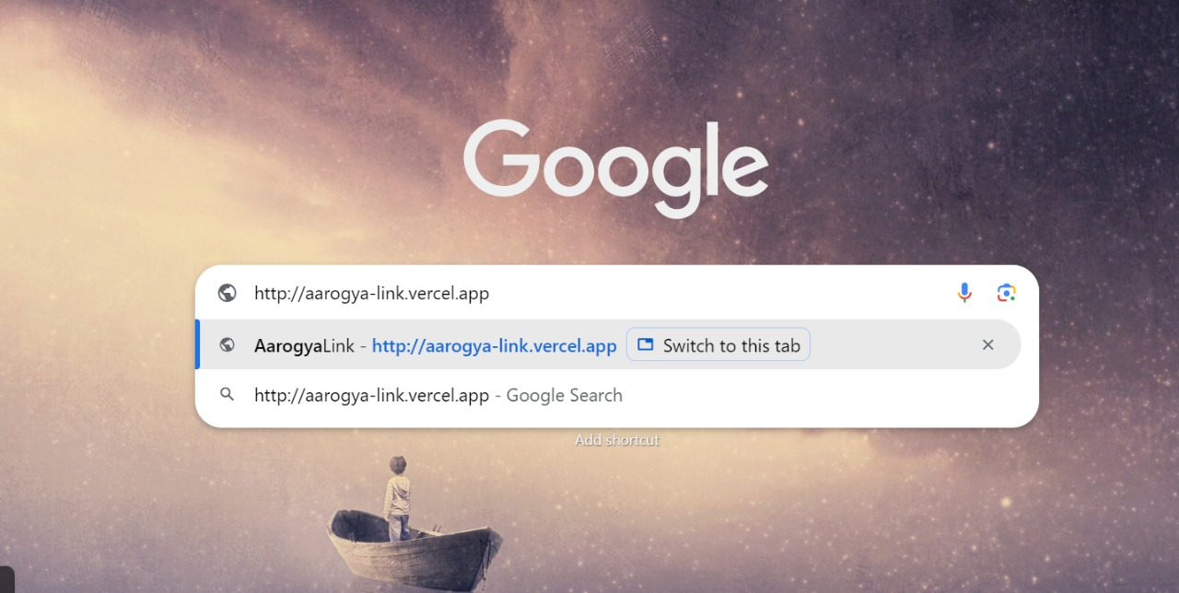
Fig 5.1 Browser Link

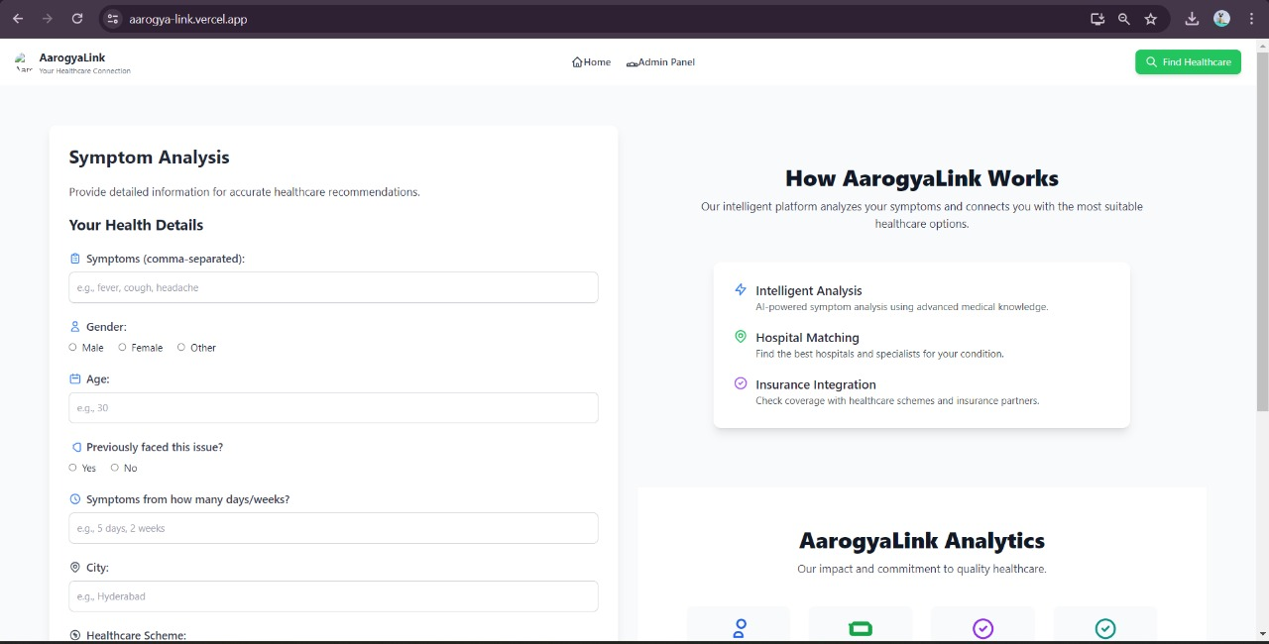
Fig 5.2 AarogyaLink Symptom Analysis Home Page

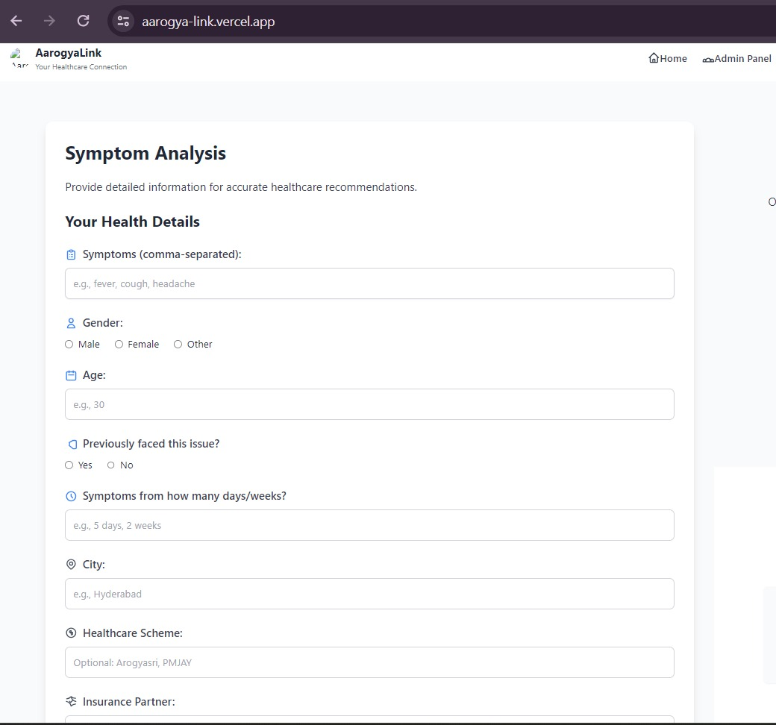
Fig 5.3 Symptom Analysis Form AarogyaLink

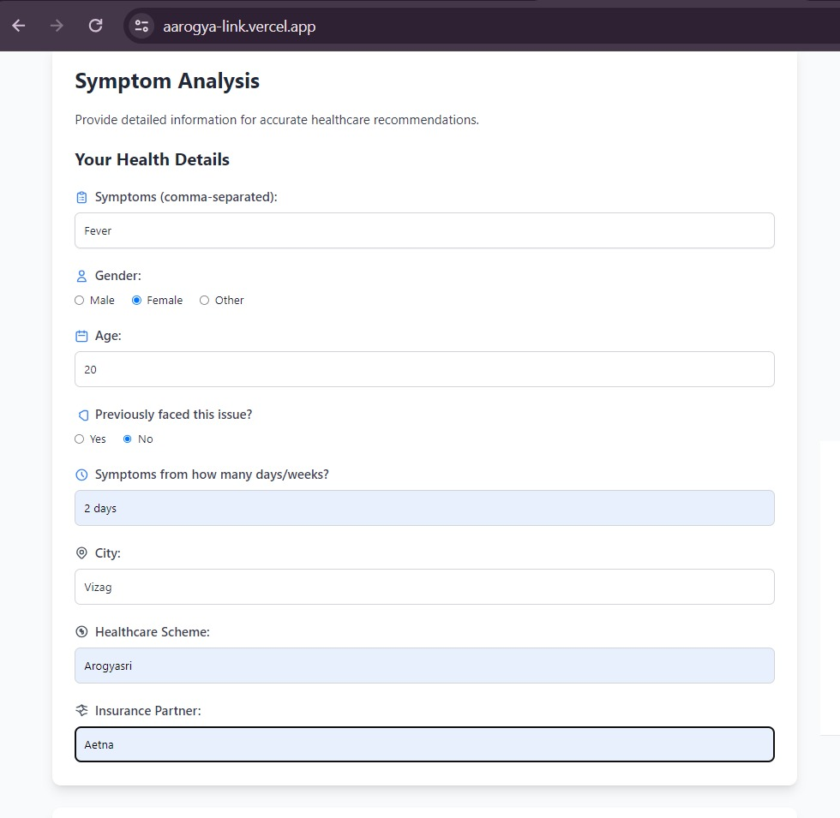
Fig 5.4 Symptom Analysis Input Form AarogyaLink
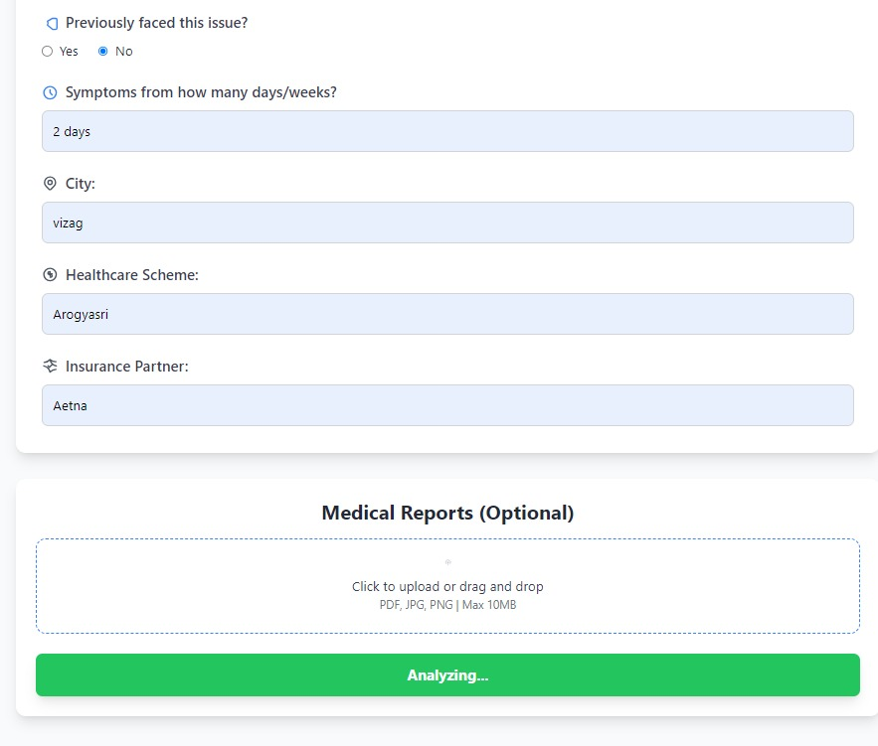
Fig 5.5 Medical Reports and Insurance Details

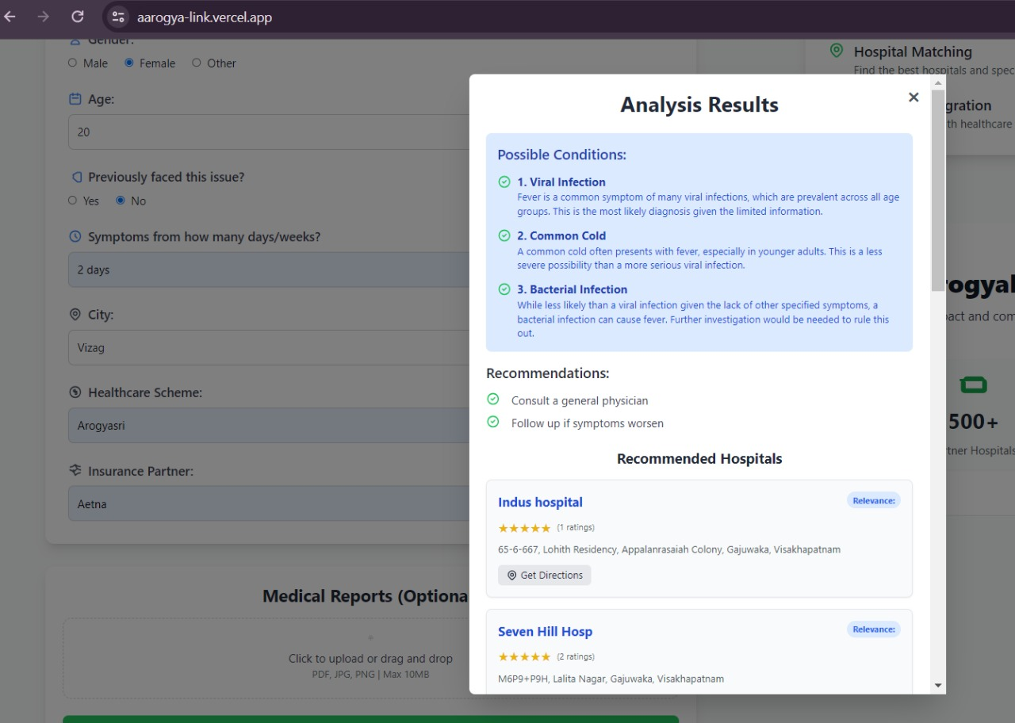

Fig 5.6 Symptom Analysis Input Form AarogyaLink

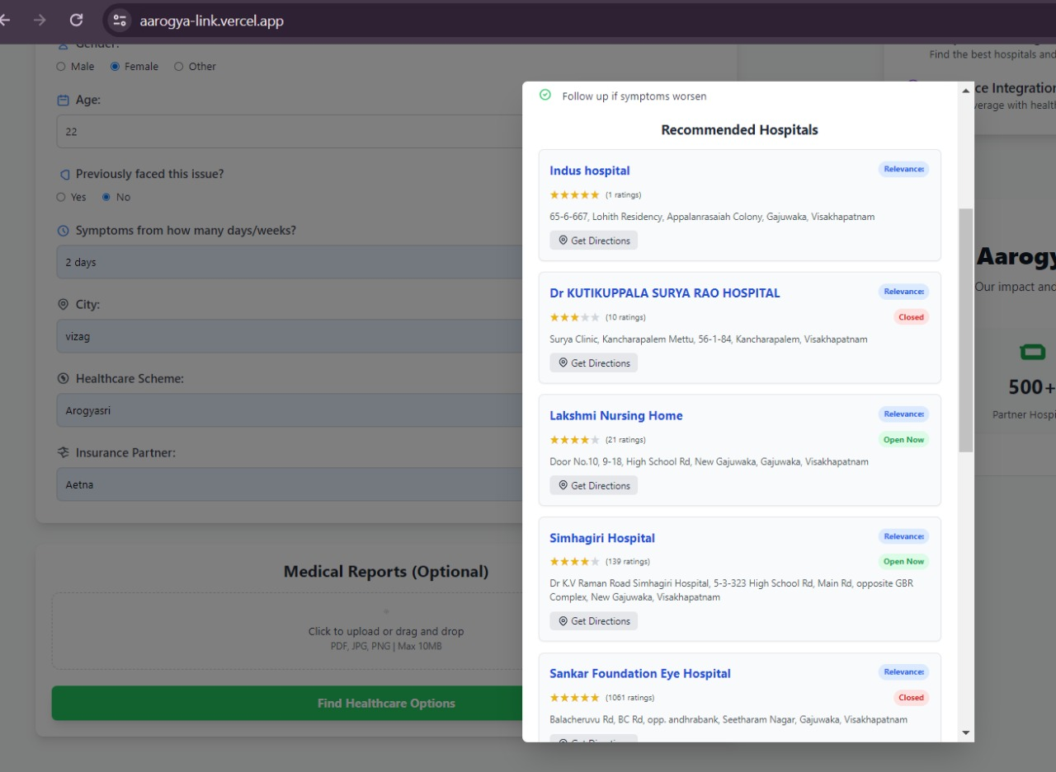

Fig 5.7 Recommended Hospitals List Based on Patient Details

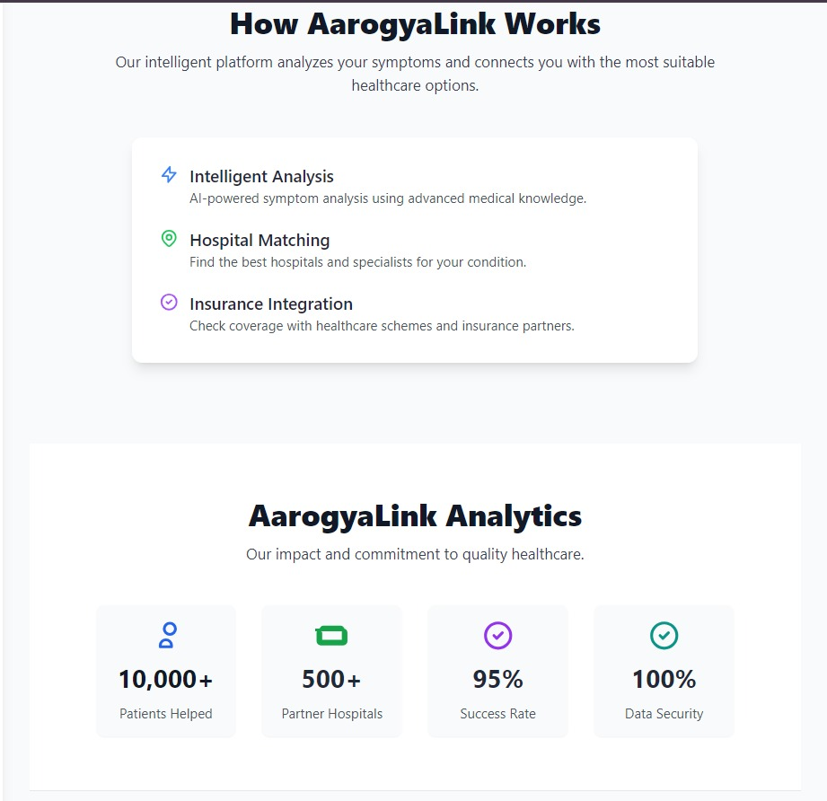
Fig 5.8 Healthcare Platform Performance
CHAPTER 6
SYSTEM TESTING

System testing was carried out to verify that AarogyaLink works as a complete and integrated application. The goal of this phase was to ensure that all modules—symptom analysis, hospital search, recommendation ranking, and the admin panel—function together without errors. The system was tested using both valid and invalid inputs to check the accuracy of the Google Gemini API in symptom diagnosis and the Google Places/Geocoding APIs in retrieving nearby hospitals. The relevance scoring algorithm was tested with different scenarios to confirm that hospitals are ranked correctly based on specialty, ratings, and availability. The admin panel was tested by adding and updating hospital entries to ensure smooth data handling. Performance tests were also performed to measure API response times, with backend optimization ensuring faster results. Security testing confirmed that API keys and sensitive data are properly protected using environment variables. Overall, the system testing phase demonstrated that AarogyaLink meets its functional, performance, and security requirements, making it ready for deployment and real-world use.

6.1 Test Cases

Test Case ID | Test Scenario | Input | Expected Output | Status
TC01 | Symptom analysis with valid input | Symptoms: "Fever, Cough" | AI returns possible conditions like Flu, Viral Infection | Pass
TC02 | Symptom analysis with empty input | Symptoms: "" | System prompts user to enter valid symptoms | Pass
TC03 | Location-based hospital search | Location: "Hyderabad" | List of nearby hospitals within city limits displayed | Pass
TC04 | Invalid location input | Location: "XYZCity" | Error message or fallback hospital list shown | Pass
TC05 | Scheme-based hospital filter | Scheme: "Aarogyasri" | Only hospitals supporting Aarogyasri are displayed | Pass
TC06 | Hospital ranking logic | Condition: "Heart Problem" | Cardiologist hospitals appear first, ranked by rating & availability | Pass
TC07 | Admin adds hospital | New hospital data entered in Admin Panel | Hospital successfully saved and shown in hospital list | Pass
TC08 | Admin enters incomplete hospital data | Missing fields in form | Error message prompts admin to fill required fields | Pass
TC09 | Performance test (API response time) | User searches symptoms & hospital | Results load within a few seconds (≤3s) | Pass
TC10 | Security test for API keys | Access system codebase | Keys hidden in .env, not exposed publicly | Pass

Test Case Design and Rationale :

TC01 – Symptom analysis with valid input
- Purpose: To confirm the AI correctly analyzes user-reported symptoms.
- Explanation: User enters symptoms like "Fever, Cough". The AI processes the input and suggests possible conditions such as Flu or Viral Infection.
- Why it matters: Accurate symptom analysis is the core functionality of the system; incorrect results would mislead users and reduce trust.

TC02 – Symptom analysis with empty input
- Purpose: To ensure the system handles empty or missing symptom input correctly.
- Explanation: User submits an empty symptom field (""). The system should prompt the user to enter valid symptoms instead of processing nothing.
- Why it matters: Prevents errors or system crashes and guides users to provide necessary input for diagnosis.

TC03 – Location-based hospital search
- Purpose: To verify the system can find hospitals based on the user’s location.
- Explanation: User enters "Hyderabad" as the location. The system searches the database and displays nearby hospitals within city limits.
- Why it matters: Ensures users get accurate and relevant hospital recommendations, improving accessibility and convenience.

TC04 – Invalid location input
- Purpose: To confirm the system handles invalid location inputs gracefully
- Explanation: User enters a non-existent location like "XYZCity". The system should show an error message or provide a fallback hospital list.
- Why it matters: Prevents system crashes and ensures users still receive helpful information even with incorrect inputs.

TC05 – Scheme-based hospital filter
- Purpose: To verify the filtering of hospitals based on healthcare schemes.
- Explanation: User selects the "Aarogyasri" scheme. Only hospitals that accept this scheme should be displayed in the results.
- Why it matters: Ensures users find hospitals compatible with their insurance or government health schemes, enhancing usability.

TC06 – Hospital ranking logic
- Purpose: To validate that hospitals are ranked correctly for specific conditions.
- Explanation: User searches for "Heart Problem". The system should display cardiology hospitals first, sorted by rating and availability.
- Why it matters: Ensures critical conditions are prioritized and users receive the best possible recommendations.

TC07 – Admin adds hospital
- Purpose: To ensure admins can successfully add new hospital data to the system.
- Explanation: Admin inputs all required hospital details in the admin panel. The system should save the hospital and show it in the hospital list.
- Why it matters: Admin inputs all required hospital details in the admin panel. The system should save the hospital and show it in the hospital list.

TC08 – Admin enters incomplete hospital data
- Purpose: To verify that incomplete hospital entries are handled correctly.
- Explanation: Admin submits a form with missing required fields. The system should prompt the admin to fill all mandatory fields.
- Why it matters: Prevents incomplete or corrupted data from entering the system, ensuring database integrity.

TC09 – Performance test (API response time)
- Purpose: To ensure the system responds quickly to user requests.
- Explanation: User searches for symptoms and hospitals. The system should return results within a few seconds (≤3s).
- Why it matters: Fast response time improves user experience and ensures the system is practical for real-time use.

TC10 – Security test for API keys
- Purpose: To verify that sensitive API keys are securely stored and not exposed.
- Explanation: Inspect the system codebase to ensure API keys are in .env files and not publicly accessible.
- Why it matters: Protects sensitive data and prevents unauthorized access, ensuring overall system security.
6.2 Results and Discussions :
The testing of AarogyaLink confirmed that the system functions as intended. The AI-based symptom analysis accurately identifies possible medical conditions when valid inputs are provided, while handling empty or invalid inputs gracefully. Hospital searches based on user location and selected healthcare schemes return relevant and precise results, and the ranking logic ensures that hospitals are displayed according to specialty, rating, and availability. Admin features, such as adding new hospitals and validating incomplete data, were executed successfully, maintaining database integrity. Performance testing demonstrated that the system responds quickly, providing results within acceptable time limits, and security checks verified that sensitive data, such as API keys, is well protected. Overall, the system proved to be reliable, efficient, and user-friendly, meeting the functional and performance requirements effectively, with potential for further optimization for scalability and response speed.

Comprehensive Testing Outcomes :

The comprehensive testing of AarogyaLink evaluated all functional, performance, and security aspects of the system. Functional testing confirmed that the AI accurately interprets user symptoms and suggests possible conditions, while handling invalid or empty inputs appropriately. The hospital search feature, based on location and healthcare schemes, consistently returned relevant and accurate results, and the ranking logic ensured hospitals were displayed in order of specialty, rating, and availability. Admin operations, including adding new hospitals and validating incomplete data, were executed successfully, maintaining the integrity of the database. Performance testing demonstrated that all responses were delivered promptly, ensuring a smooth user experience. Security evaluations verified that sensitive data, such as API keys, were properly protected. Overall, the testing outcomes indicate that the system is robust, reliable, and efficient, effectively meeting the intended requirements and providing a strong foundation for real-world usage.

6.2.1 Datasets:

- Google Gemini API

Description: An AI-powered service that analyzes user-reported symptoms and provides possible medical conditions. It replaces the need for a static symptom–disease dataset by dynamically generating diagnostic suggestions.

Utility: Enables real-time symptom analysis without maintaining a separate symptom–disease dataset. Ensures the system can provide accurate and updated AI-based suggestions.

- Google Places API

Description: Provides real-time information about hospitals, including location, contact details, ratings, and operational status.

Utility: Acts as a live dataset for hospitals near the user, supporting location-based searches and ensuring up-to-date hospital information.

- Google Geocoding API

Description: Converts user-entered city names or addresses into precise geographic coordinates (latitude and longitude).

Utility: Serves as a location dataset, allowing accurate mapping and nearby hospital searches based on user location.

- Hospital Data Store (Custom / Administrative Panel)
Description: A custom dataset maintained via the admin panel, containing details about hospitals, including supported government healthcare schemes and insurance plans.
Utility: Enables filtering and ranking hospitals based on schemes, insurance coverage, and other administrative data, ensuring accurate recommendations to users.

6.3 Performance Evaluation :

The performance of AarogyaLink was evaluated in terms of accuracy, efficiency, usability, and reliability. The system generated relevant diagnosis suggestions and correctly matched hospitals with the selected healthcare schemes, ensuring accuracy. It responded smoothly to user inputs, showing good efficiency. The interface was found to be simple and mobile-friendly, which improved usability. Deployment on reliable platforms ensured stable operation, while HTTPS secured data handling. Overall, the system performed effectively and met its intended objectives.

6.3.1 Accuracy

Symptom Analysis: The correctness of AI-powered diagnosis was tested using the Google Gemini API. Its results were compared with standard medical symptom–disease datasets and benchmark cases to ensure reliability.
The Hospital Recommendations: precision of suggested hospitals was verified based on user location and healthcare scheme filters. Recommendations were checked against actual hospital policies to confirm that listed hospitals truly accept the selected schemes/insurances.

6.3.2 Efficiency
Response Time: The system was observed to return results smoothly and without delays, ensuring a quick user experience.
System Scalability: Load and stress testing confirmed that the system can handle multiple concurrent requests while maintaining stable performance.

6.3.3 Usability
Ease of Use: User feedback confirmed that the application is simple and intuitive, requiring minimal effort to enter symptoms and receive recommendations.
Navigation & Accessibility: The interface is responsive across devices (mobile, tablet, desktop) with a clear design, enhancing the overall user experience.

6.3.4 Reliability
Uptime: With deployment on Vercel (frontend) and Render (backend), the system maintained consistent and reliable performance.
Data Consistency: Hospital scheme and insurance information stored in the admin panel was validated against actual hospital data to ensure trustworthiness.

6.3.5 Security & Privacy
Secure Data Transfer: All communication between the system and external APIs is encrypted via HTTPS, ensuring confidentiality of user data.
User Privacy: The system avoids unnecessary storage of personal or sensitive medical data, retaining only what is essential for generating recommendations.

Real World Implications
The development of AarogyaLink carries strong real-world significance, especially in the healthcare sector where accessibility and affordability remain major challenges. The system helps patients by providing quick and reliable hospital recommendations based on their symptoms, location, and available healthcare schemes. This reduces the confusion and delay that many individuals face when deciding where to seek treatment, particularly during emergencies when time is critical.
One of the most valuable contributions of the platform is its ability to bridge the gap between patients and healthcare schemes. By integrating government health initiatives and insurance details into the recommendation process, the system ensures that patients are directed to hospitals where they can actually avail financial benefits. This not only promotes the effective use of such schemes but also makes healthcare more affordable and inclusive for underprivileged communities.
The real-world impact extends beyond individual patients as well. On a larger scale, the application has the potential to serve as a scalable tool for public health management. As usage increases, the system can generate insights into patient trends, hospital utilization, and geographical gaps in healthcare infrastructure. Such information can support policymakers, NGOs, and healthcare providers in planning better services.
Furthermore, AarogyaLink demonstrates how AI-powered healthcare applications can be implemented responsibly, with a focus on user privacy. By ensuring secure data handling and limiting the storage of personal information, the system builds trust while showcasing the role of technology in solving critical social problems. Overall, the platform has the potential to make healthcare delivery more efficient, accessible, and affordable in real-world scenarios.

CHAPTER 7
CONCLUSION & FUTURE SCOPE

7.1 Conclusion:

The AarogyaLink project provides a smart and reliable solution for healthcare navigation by combining AI-driven symptom analysis with real-time hospital recommendations. With features like scheme and insurance filtering, hospital suggestions, and an administrative panel, the system makes healthcare both accessible and financially transparent. By addressing the limitations of existing tools and ensuring user-friendly access through modern technologies, AarogyaLink succeeds in bridging the gap between patients and healthcare providers.

Achievements and Impact

    - Achievements
- Integration of AI Technology: The system successfully integrated the Google Gemini API to provide AI-based symptom analysis, giving patients accurate and meaningful diagnosis suggestions.
- Real-Time Hospital Search: Google Places and Geocoding APIs were implemented to enable real-time hospital searches, ensuring patients receive nearby and accessible recommendations.
- Financial Transparency: A scheme and insurance filtering feature was added to allow patients to choose hospitals that support their financial coverage.
- Smart Recommendations: The platform introduced a recommendation mechanism that ranks hospitals based on distance, specialty, user ratings, and scheme compatibility.
- Administrative Features: An administrative panel was developed for hospitals, allowing them to update services, schemes, and other details in real time.
- Deployment Success: The system was deployed using Vercel for the frontend and Render for the backend, achieving scalability, high uptime, and reliability.

    - Impacts
- Improved Accessibility
The project simplifies healthcare access by combining AI-driven diagnosis and hospital search into a single platform.
- Time-Saving for Patients
Patients save time through filtered and ranked hospital recommendations, avoiding the need to manually compare multiple options.
- Financial Support
The inclusion of scheme and insurance filtering reduces financial uncertainty by displaying only compatible hospitals.
- Transparency and Trust
By keeping hospital data up to date and reliable, the system builds transparency and strengthens patient trust.
7.2 Future Scope
    - Mobile Application Development: The system can be extended into a dedicated mobile app, making healthcare access even more convenient for patients on the go.
    - Multilingual Support: Adding support for multiple regional languages will help users from diverse backgrounds easily understand and use the platform.
    - Integration with Electronic Health Records (EHR): Future versions can connect with electronic medical records to give patients and doctors a complete view of health history.
    - Telemedicine Services: The platform can be enhanced with video consultation and live chat features, allowing patients to directly consult with doctors online. This will reduce the need for in-person visits in non-critical cases and make healthcare more accessible in remote areas.
    - Expanded Scheme and Insurance Database: Currently, the system filters hospitals using basic scheme and insurance details. In the future, it can integrate a broader database of national and private health insurance policies, making financial planning more transparent and reducing patient stress.
    - AI Enhancement and Predictive Analytics: Future updates can include more advanced AI models that not only diagnose symptoms but also predict potential health risks. Predictive analytics can help in early detection of diseases and offer preventive care recommendations to patients.
    - Global Expansion: Although designed for Indian healthcare schemes, the framework can be expanded internationally. By integrating foreign insurance models and global hospital databases, AarogyaLink can serve as a universal health navigation tool.
    - Wearable Device Integration: The system can be connected with wearable devices such as smartwatches and fitness trackers. This would allow real-time monitoring of patient health data like heart rate, oxygen levels, or physical activity, and provide instant alerts in case of abnormalities.
    - Pharmacy and Lab Integration: Future versions may include partnerships with pharmacies and diagnostic labs, allowing patients to order medicines online or book lab tests directly through the platform. This would make AarogyaLink a complete healthcare ecosystem.
    - Emergency Assistance Features: The system can be expanded to include emergency services like ambulance booking, nearest blood bank locator, and SOS alerts to family members. Such features would increase the reliability of the system in life-threatening situations.

CHAPTER 8
REFERENCES

1. API / AI References
Google Gemini API Documentation – for symptom analysis & AI diagnosis
(https://developers.google.com/gemini)
Axios HTTP library – used for making API requests in Node.js
(https://axios-http.com/)

2. Frontend / UI References
React Official Documentation – for building the frontend
(https://reactjs.org/docs/getting-started.html)
React Router – for page routing
(https://reactrouter.com/en/main)

3. Backend / Database References
Node.js Documentation – for server-side JavaScript
(https://nodejs.org/en/docs/)
Express.js Documentation – for building APIs
(https://expressjs.com/)
MongoDB / Mongoose Documentation – for database schema & operations
(https://mongoosejs.com/docs/guide.html)

